BOARDROOM BRIEFING REPORT
Global Teen Social Media Behaviour & Digital Wellbeing Dashboard
A data-driven intelligence brief for NGOs, education leaders, child protection stakeholders, and digital wellbeing partners
Prepared for: Boardroom, NGO, Programme Strategy and Partnership Review
Board Summary Item | Description
Dataset scope | 98 countries, 14 regions, 2015-2060 trend horizon
Dashboard format | Static interactive HTML/CSS/JavaScript dashboard deployed through GitHub Pages
Primary purpose | Identify teen digital wellbeing risks and guide evidence-informed intervention planning
Strategic audience | NGO boards, programme directors, school networks, donors, child protection partners, policy advocates
Note: The project uses synthetic/analytical datasets for modelling, portfolio demonstration, policy simulation and dashboard development. Findings should guide discussion and programme design, not replace nationally validated survey evidence.

1. Executive Summary
This report presents a boardroom-ready analysis of the Global Teen Social Media Behaviour and Digital Wellbeing Dashboard. The dashboard consolidates country, regional, urban-rural, behavioural segment, forecast, and feature-importance datasets into an interactive monitoring tool for understanding the relationship between teen screen time, social media exposure, addiction risk, sleep patterns, cyberbullying, mental health risk, and digital wellbeing.
The central value of the project is not only technical. It is a decision-support product for organisations seeking to design safer digital environments for adolescents. For NGOs, schools, youth-focused foundations, and child protection coalitions, the dashboard can support advocacy, early warning, programme targeting, stakeholder reporting, donor presentations, and campaign planning.
Board-Level Decision Message
Teen digital wellbeing should be treated as a measurable youth development and mental health priority, not simply a technology-use issue.
The strongest risk signals in the model relate to social media addiction, smartphone dependency, time spent on social media, daily screen time, eye strain, sleep hours, notifications, and night screen use.
The dashboard can help NGOs prioritise intervention by country, region, population setting, behavioural segment, and forecasted future risk.
The project is suitable for boardroom demonstration, donor engagement, research communication, and digital wellbeing programme planning.
Headline Indicators
Indicator | Value
Countries covered | 98
Regions covered | 14
Country-year records | 4,508
Average screen time, 2015 | 3.66 hours/day
Average screen time, 2026 | 4.66 hours/day
Average screen time, 2060 projection period | 7.82 hours/day
Average sleep, 2015 | 7.90 hours/day
Average sleep, 2060 projection period | 6.90 hours/day
2. Background and Strategic Rationale
Across education, public health, child protection, and youth development sectors, adolescent online behaviour has become a strategic concern. Social media and smartphones have created access to information, peer connection, creativity, and learning opportunities. However, excessive or poorly regulated use may also contribute to sleep disruption, exposure to harmful content, cyberbullying, reduced attention, academic strain, anxiety, and poor digital wellbeing.
NGOs often need to present complex digital behaviour evidence to boards, donors, schools, parents, and policy stakeholders. Raw spreadsheets are not effective for that purpose. This project transforms multi-dimensional teen digital behaviour data into a visual dashboard that allows non-technical stakeholders to explore risks quickly and ask better programme questions.
Why This Matters for NGOs
Programme targeting: identify countries, regions, and youth segments requiring deeper assessment or intervention.
Advocacy: communicate digital wellbeing risks with clear visuals instead of lengthy technical tables.
Donor reporting: demonstrate evidence-informed planning and measurable risk indicators.
Partnership development: support conversations with schools, ministries, parent associations, and technology partners.
Monitoring and evaluation: create a framework for tracking screen time, wellbeing, cyberbullying and behavioural risk over time.
3. Data Assets and Methodology
The project uses a collection of CSV datasets covering global teen social media behaviour from 2015 to 2060. The main dashboard does not rely on the very large raw file; instead, it uses smaller summary datasets to improve loading performance on GitHub Pages and ensure broader accessibility for board members and external stakeholders.
Dataset | Analytical Purpose
country_year_summary_2015_2060.csv | Country-year trend analysis across screen time, sleep, addiction, mental health risk, wellbeing, cyberbullying and problematic use.
global_country_risk_rankings_2026.csv | Country-level 2026 risk ranking for boardroom comparison and prioritisation.
global_forecast_2030_2040_2050_2060.csv | Long-term forecast scenarios for addiction and mental health risk.
region_2026_risk_profile.csv | Regional risk comparison across addiction, mental health, wellbeing, cyberbullying and harmful content.
regional_urban_rural_risk_summary_2026.csv | Urban, semi-urban and rural comparison of digital risk indicators.
teen_behaviour_segments.csv | Behavioural segmentation based on screen time, social media use, sleep, risk scores and wellbeing.
model_feature_importance.csv | Model explanation showing the strongest predictors of risk in the dataset.
Analytical Approach
Data cleaning and structuring: CSV files were organised into dashboard-ready tables.
Descriptive analytics: averages, rankings, trends and grouped summaries were produced for board-level interpretation.
Comparative analytics: countries, regions and urban-rural groups were compared across risk indicators.
Forecast analysis: projected risk indicators for 2030, 2040, 2050 and 2060 were reviewed.
Dashboard development: the final interactive version was converted to HTML, CSS and JavaScript for GitHub Pages deployment.
4. Key Analytical Findings
4.1 Global Trend: Screen Time Is Rising While Sleep and Digital Wellbeing Decline
Between 2015 and 2026, average screen time increased from 3.66 to 4.66 hours per day. By the 2060 projection period, the average rises to 7.82 hours per day. At the same time, average sleep declines from 7.90 hours in 2015 to 6.90 hours by 2060. Digital wellbeing also falls from 88.76 in 2015 to 71.43 by 2060.
Average addiction score rises from 43.36 in 2015 to 67.32 by 2060.
Average mental health risk rises from 35.21 in 2015 to 48.14 by 2060.
Problematic use rate rises from 1.0% in 2015 to 40.3% by 2060.
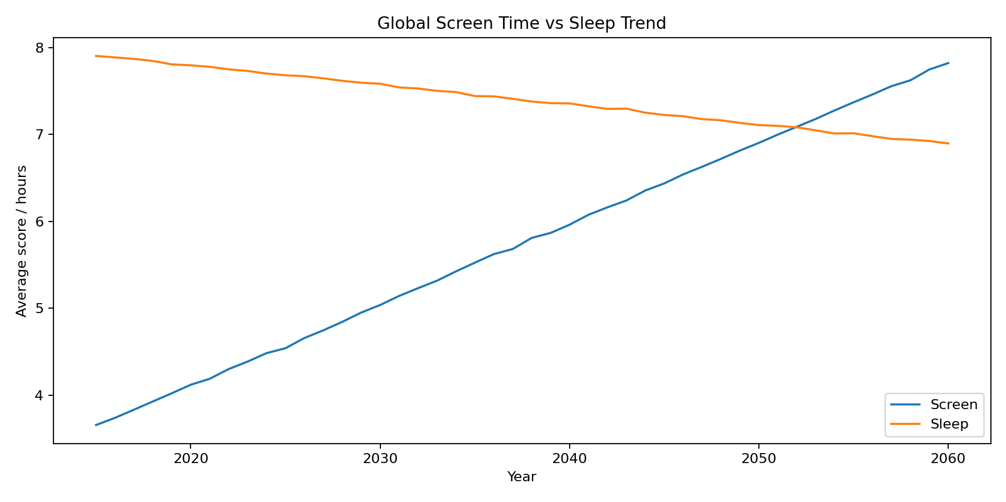
Figure 1: Screen time and sleep trend comparison.
4.2 Country Risk Ranking: 2026 High-Risk Countries Require Further Review
The 2026 country ranking identifies countries with comparatively higher overall risk scores. This ranking should be used to prioritise deeper research, stakeholder consultation, and context-specific programme planning, rather than as a final judgement of national performance.
Rank | Country | Region | Overall Risk | Addiction | Mental Health Risk
1 | Portugal | Southern Europe | 37.63 | 52.27 | 40.00
2 | Spain | Southern Europe | 37.29 | 50.83 | 39.82
3 | United Kingdom | Western Europe | 37.23 | 53.64 | 39.75
4 | Kuwait | Middle East | 37.17 | 50.85 | 39.85
5 | China | East Asia | 37.06 | 51.59 | 39.88
6 | Guatemala | Latin America | 36.93 | 50.92 | 39.65
7 | Costa Rica | Latin America | 36.93 | 51.04 | 39.77
8 | United States | North America | 36.79 | 51.02 | 38.69
9 | Uruguay | Latin America | 36.72 | 50.16 | 39.51
10 | Switzerland | Western Europe | 36.70 | 50.90 | 39.19
4.3 Regional Pattern: Southern Europe, Western Europe and East Asia Lead on Addiction Score
Regional comparison shows that several high-income and digitally saturated regions display elevated addiction scores. This indicates that digital wellbeing risk is not limited to low-resource settings. Programme design should therefore consider both access-related issues and overuse-related issues.
Continent | Region | Screen Time | Addiction | Mental Risk | Digital Wellbeing
Europe | Southern Europe | 5.00 | 50.94 | 39.30 | 83.41
Europe | Western Europe | 4.92 | 50.33 | 38.83 | 84.12
Asia | East Asia | 4.72 | 50.11 | 38.68 | 84.17
Asia/Europe | Middle East | 4.82 | 50.08 | 38.73 | 83.55
North America | Latin America | 4.80 | 50.03 | 38.98 | 83.80
North America | North America | 4.91 | 50.03 | 38.37 | 84.07
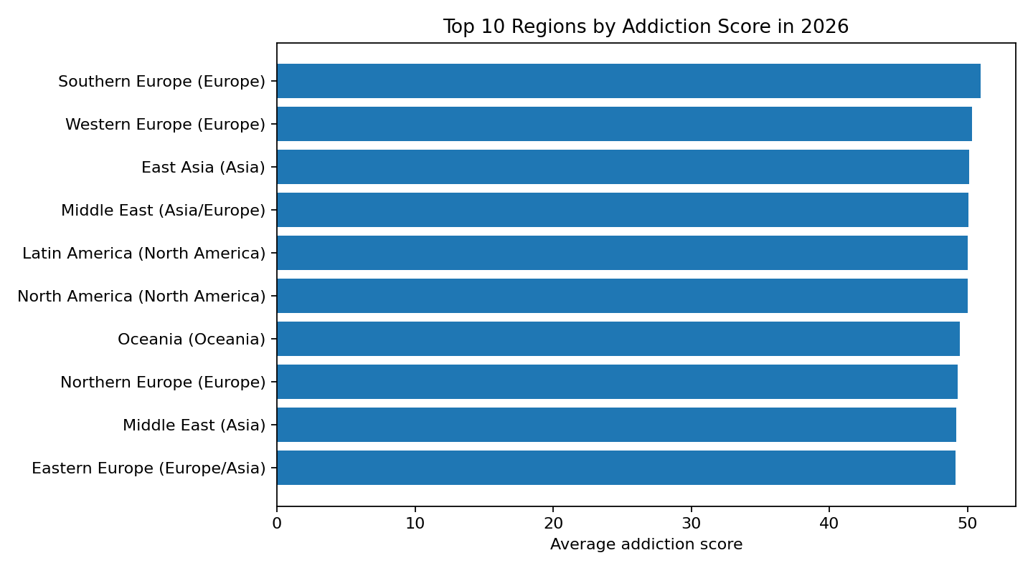
Figure 2: Top regional addiction scores in 2026.
4.4 Urban-Rural Pattern: Urban Teens Show Higher Average Addiction Score
Urban and semi-urban groups show higher average screen time and addiction scores than rural groups. This is consistent with a likely combination of stronger device access, more stable connectivity, higher notification exposure, and greater integration of digital platforms into daily routines.
Setting | Screen Time | Addiction | Mental Risk | Wellbeing | Cyberbullying
Rural | 4.41 | 47.72 | 37.70 | 85.87 | 0.16
Semi-urban | 4.63 | 48.78 | 38.02 | 84.85 | 0.15
Urban | 4.74 | 49.20 | 38.36 | 84.55 | 0.15
4.5 Behavioural Segments: Sleep-Disrupted Heavy Users Are the Highest Priority Group
The behaviour segmentation highlights one especially important intervention group: Sleep Disrupted Heavy Users. This group records the highest daily screen time, highest social media hours, lowest sleep, highest addiction score, highest mental health risk, and lowest digital wellbeing. For NGO programming, this segment represents a high-priority target for school-based digital wellbeing interventions, sleep hygiene programmes, parent engagement and counselling referral pathways.
Segment | Records | Screen Time | Social Media | Sleep | Addiction | Mental Risk
Digitally Active but Supported | 22774 | 5.94 | 3.12 | 7.40 | 55.59 | 41.70
Digitally Active but Supported | 55647 | 4.01 | 1.94 | 8.07 | 41.15 | 33.41
Sleep Disrupted Heavy Users | 34661 | 7.76 | 4.70 | 6.50 | 74.37 | 52.62
Digitally Active but Supported | 66362 | 6.04 | 3.16 | 7.31 | 56.70 | 42.61
Digitally Active but Supported | 20556 | 5.82 | 3.04 | 7.41 | 55.24 | 41.53
5. Predictive and Forecast Insights
5.1 Strongest Risk Drivers
The feature-importance file indicates that the most influential predictor is social media addiction score, followed by smartphone dependency score, social media hours, daily screen time, eye strain, sleep hours, notifications, night screen time, fear of missing out and attention span. These drivers are practical because they can be translated into intervention indicators and monitoring tools.
Feature | Importance
Social Media Addiction Score | 0.253
Smartphone Dependency Score | 0.153
Social Media Hours | 0.111
Daily Screen Time Hours | 0.071
Eye Strain Score | 0.057
Sleep Hours | 0.053
Daily Notifications | 0.045
Night Screen Time Hours | 0.040
Fear Of Missing Out Score | 0.036
Attention Span Minutes | 0.033
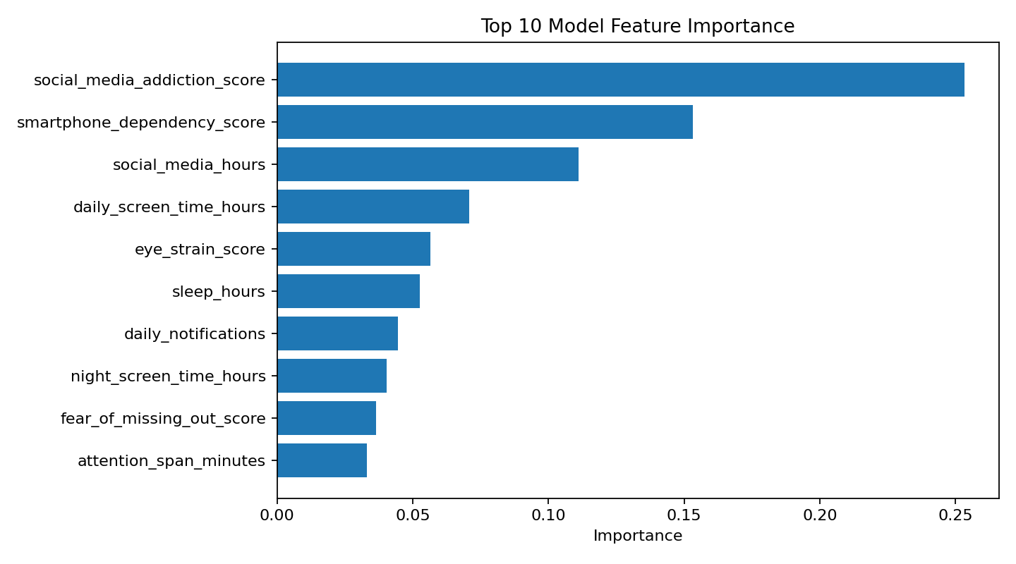
Figure 3: Top model feature importance indicators.

5.2 Forecast Implications
Forecast averages suggest an increase in addiction risk from 55.18 in 2026 to 67.08 by 2060. Mental health risk is projected to increase from 41.57 in 2026 to 50.50 by 2060. These projections strengthen the case for early preventive interventions rather than waiting until digital risk becomes a crisis management issue.
Period | Mean Addiction Risk | Mean Mental Health Risk
2026 baseline | 55.18 | 41.57
2030 projection | 56.58 | 42.62
2040 projection | 60.08 | 45.25
2050 projection | 63.58 | 47.87
2060 projection | 67.08 | 50.50
6. Dashboard Product Overview
The final dashboard was converted from a Python Dash prototype into a static interactive HTML/CSS/JavaScript product. This allows the dashboard to be hosted on GitHub Pages without requiring a Python server, Render deployment, or paid infrastructure. The dashboard is suitable for boardroom demonstration because it opens through a normal browser link.
Dashboard Modules
- Executive KPI cards showing headline records, countries, regions and average screen time.
- Country selector enabling users to update trend and forecast views interactively.
- Trend chart showing screen time, sleep, addiction and mental health risk over time.
- Top 10 high-risk country ranking chart for board-level prioritisation.
- Regional addiction comparison chart.
- Urban versus rural addiction risk chart.
- Forecast analytics for long-term risk discussion.
- Behaviour segmentation visualisation.
- Searchable country risk overview table.
Technical Stack
Layer | Technology / Approach
Data preparation | Python, Pandas, CSV summary files
Visualisation prototype | Plotly charts and dashboard layout design
Final web version | HTML5, CSS3, JavaScript, Plotly.js and PapaParse
Hosting approach | GitHub Pages static web deployment
Accessibility advantage | Runs in browser without Python installation for end users
7. Recommendations for NGO and Board Action
7.1 Programme Recommendations
Launch a school-based digital wellbeing pilot focused on screen-time awareness, sleep hygiene, online safety and responsible social media use.
Create a teen digital wellbeing curriculum module for schools and youth centres.
Prioritise Sleep Disrupted Heavy Users as a high-risk intervention group.
Develop parent education sessions on night screen use, notifications, device boundaries and cyberbullying response.
Integrate digital wellbeing screening into youth counselling, mentorship and school support programmes.
Build referral partnerships with counsellors, child psychologists and child protection professionals for high-risk cases.
7.2 Advocacy and Partnership Recommendations
Use dashboard visuals for donor briefings, policy roundtables, school board presentations and child online safety campaigns.
Partner with schools, parent-teacher associations, youth clubs, religious organisations and community leaders to localise interventions.
Develop annual digital wellbeing scorecards for programme areas.
Advocate for balanced digital literacy policies that address both opportunity and risk.
Encourage responsible technology use without demonising social media or young people.
7.3 Data and Research Recommendations
Follow this synthetic model with real survey collection from schools and communities.
Add age, gender, school level, device ownership, parental monitoring, internet access and socioeconomic variables to future data collection.
Create a consent-aware and child-safe data collection protocol.
Validate risk thresholds with mental health and education professionals.
Track outcomes before and after programme implementation.
8. Proposed Implementation Roadmap
Phase | Core Activities | Indicative Timeline
Phase 1: Board approval | Present dashboard, approve pilot objectives, define governance and safeguarding responsibilities. | 2-4 weeks
Phase 2: Stakeholder validation | Engage schools, parents, counsellors, youth representatives and digital safety partners. | 1-2 months
Phase 3: Local data collection | Collect real baseline data using ethical youth survey protocols. | 2-3 months
Phase 4: Pilot intervention | Implement school and community digital wellbeing sessions. | 3-6 months
Phase 5: Monitoring and evaluation | Measure changes in screen time, sleep, cyberbullying awareness and wellbeing indicators. | Ongoing
Phase 6: Scale-up | Expand to more schools/regions and produce annual dashboard updates. | 6-12 months
9. Limitations and Ethical Considerations
The dashboard is a decision-support and communication tool. Because the data is synthetic/analytical, it should be used for modelling, demonstration, planning and stakeholder engagement rather than final public claims about specific countries or communities. Before operational use, an NGO should validate the trends with primary data, school surveys, expert review and local context analysis.
- Avoid labelling countries, regions or youth groups as problematic without contextual interpretation.
- Use child safeguarding principles when collecting or discussing teen digital behaviour data.
- Protect student privacy and avoid collecting unnecessary personally identifiable information.
- Frame the issue as support, education and wellbeing, not blame or punishment.
- Ensure that interventions consider both online opportunity and online risk.
10. Boardroom Decision Points
The board is invited to consider whether the dashboard should be adopted as a strategic communication and planning tool for digital wellbeing programming. The following decisions are recommended for discussion:
- Approve the dashboard for use in internal strategy meetings, donor discussions and programme design workshops.
- Approve a pilot digital wellbeing initiative for selected schools or youth communities.
- Approve the development of a real-world baseline survey instrument to validate local teen digital wellbeing indicators.
- Mandate a child safeguarding and data protection review before collecting primary data from minors.
- Identify strategic partners across education, mental health, child protection and technology sectors.
Conclusion
The Global Teen Social Media Behaviour and Digital Wellbeing Dashboard provides a practical bridge between data analysis and social impact decision-making. It enables NGOs and board-level stakeholders to move from general concern about social media use to structured insight, prioritised intervention, evidence-based communication and measurable programme planning. With validation through local data and ethical implementation, the project can support stronger digital wellbeing programmes for adolescents.

